Making the Inkjet

Oliver Kesterton – September 205

Most of the room temperature inkjets were printed on an Ormerod 2 3D printer, and could be used straight as printed parts. The included STL files for these will work. For best results, print at 100% infill to ensure they are watertight. All holes that need to be threaded can be tapped with a bolt. The latest designs use turned brass tube adapters to connect silicone tubing to the inkjet. These are simply 4mm rod, with a section turned down to 3mm and a thread cut. A 1.2mm hole is then drilled through the whole part.

This image shows a printed inkjet mounted on the Ormerod:

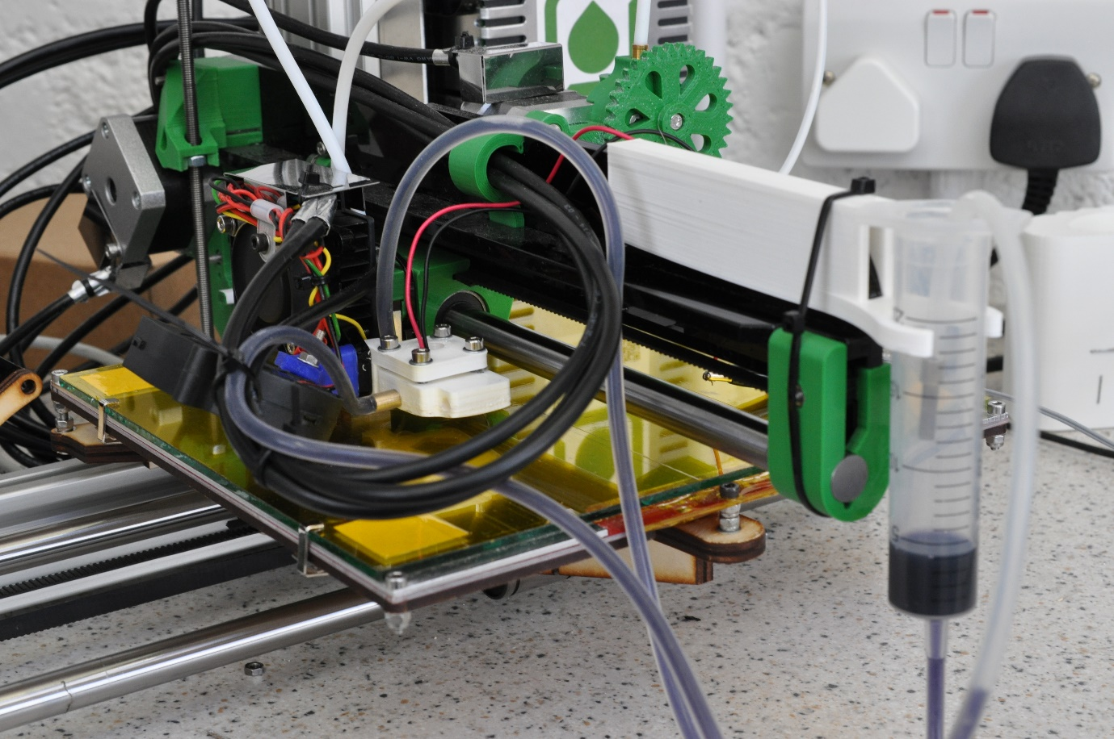

Some experimentation was done into casting the inkjet in resin. This ensured that they were watertight. The heated inkjet was cast in an aluminium filled resin (Alchemix EP425), which is thermally stable up to 160 degrees C. However, its thermal conductivity remains poor, so it is far from an ideal solution.

